Your Lone Dog Calendar
20 points
Directions: In any medium, create a calendar similar to Lone Dog’s to represent the years of your life. Pick an important event of that year for your country, state, city, or family. | 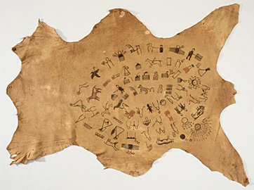

 | 5 points | 3 points | 0 point
Design/Appearance | The calendar is exceptionally designed for easy viewing. The content is well thought out and the sequencing makes sense. | The calendar is well designed for easy viewing. The content shows a clear overall plan. | The design of the calendar makes it hard to view and follow the information.
Classroom Participation | Consistently stays focused on in-class work and what needs to be done. Very self-directed. | Focuses on in-class work and what needs to be done most of the time. | Focuses on the task and what needs to be done some of the time. Often must be reminded by the teacher about what needs to get done.
Choice of Events | All events chosen were important to the year. | All events except one or two events were important to the year | Three or more events were not important the year.
Checklist | All items in the checklist are complete and accurate. | All items in the checklist are complete and accurate. | One or more items on the checklist are missing.

Checklist:
One picture for each year you have been alive
The Pictures are displayed in a spiral format
An information Page: Descriptions for each picture on a second page are complete to understand each picture.

